Warehouse Shipment to Sales order and history tables value flow:

Sales order:

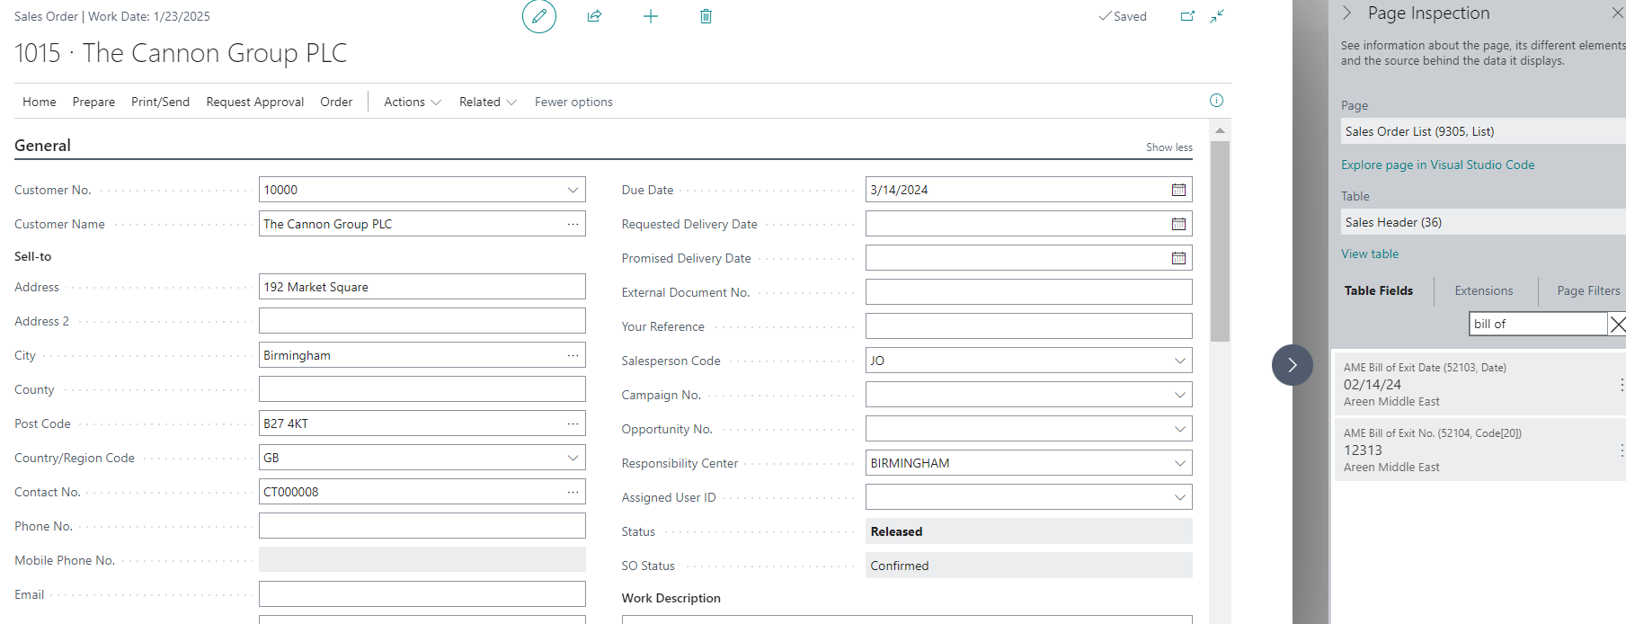

Posted Sales Shipment :

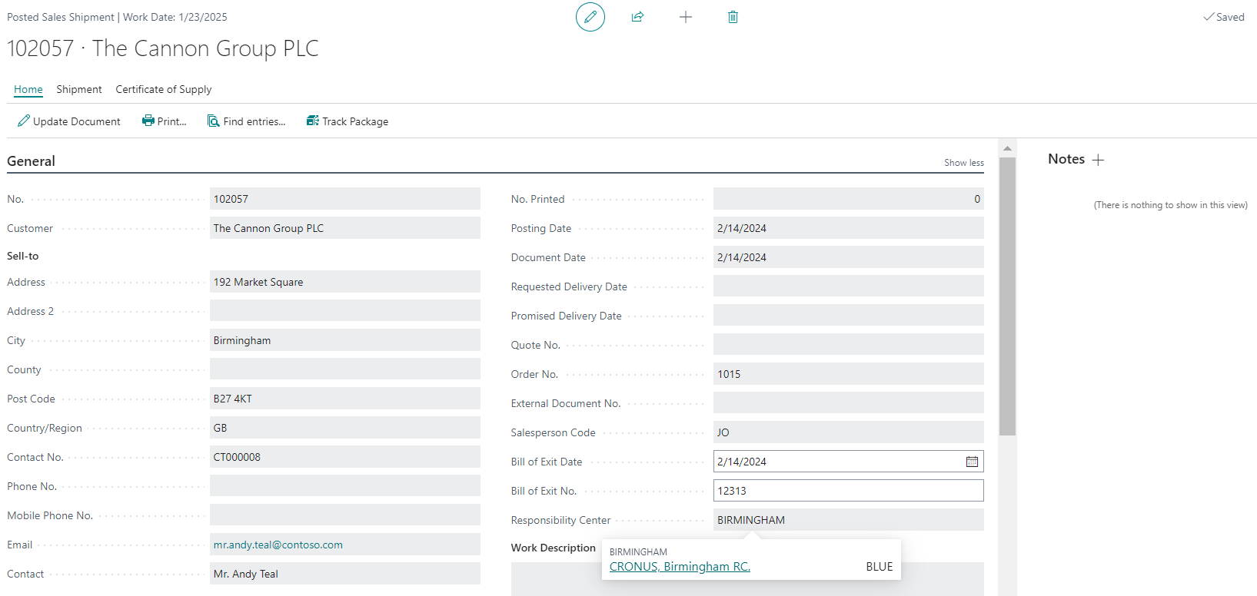

Posted Sales Invoice:

